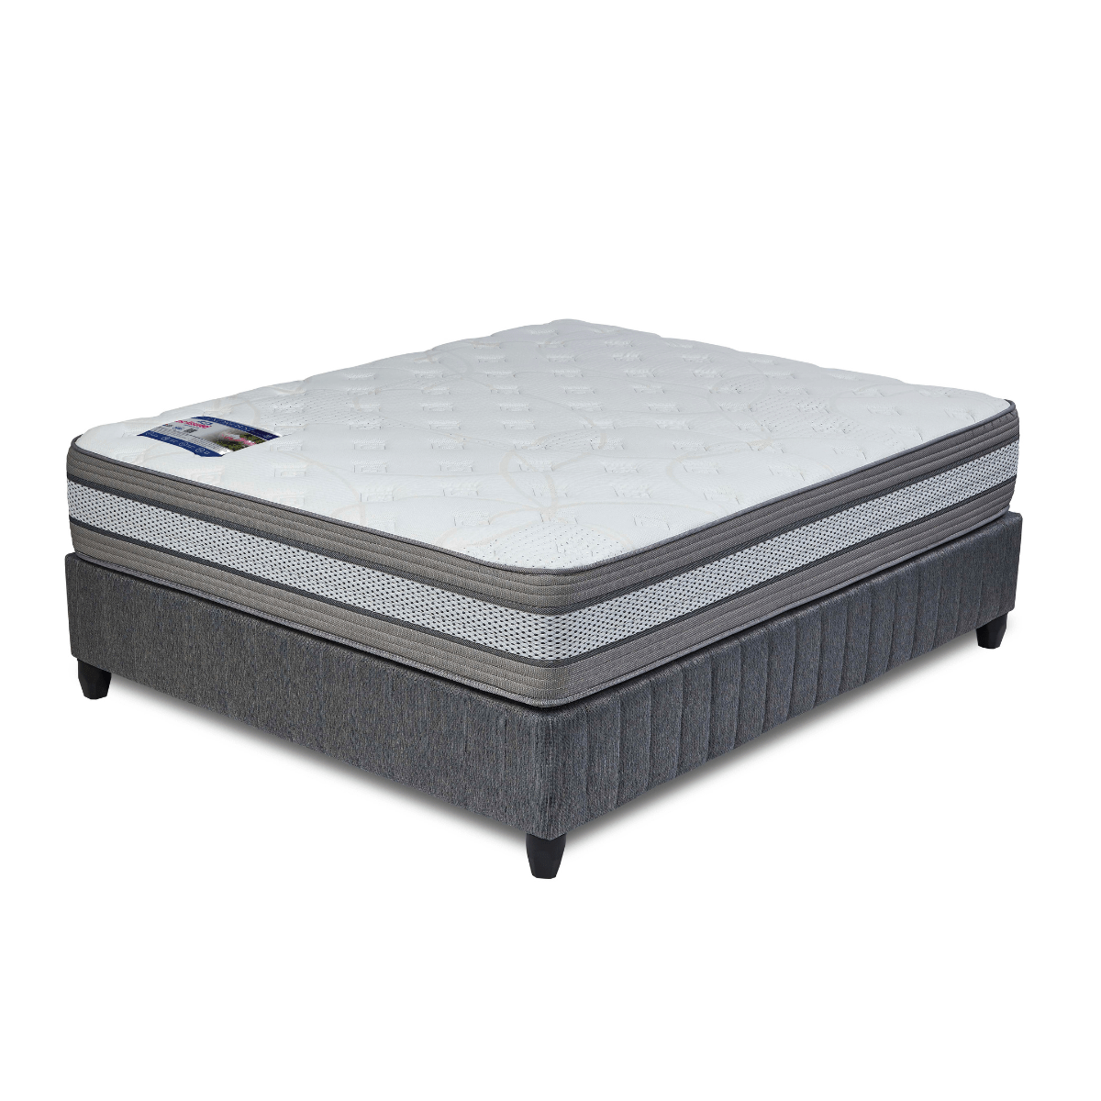
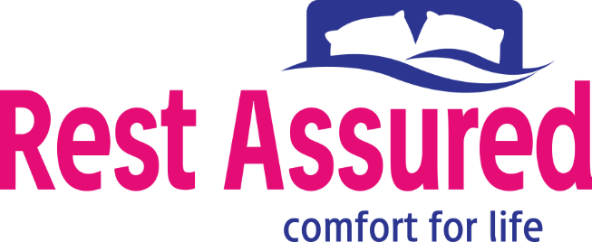

Model : ST Andrews Base Set
Supplier/Manufacturer : Rest Assured
Range : Evolution Pocket Spring Collection
Prices – Bed Set :
- Single Bed Set – R8819
- Three Quarter Bed Set – R10049
- Double Bed Set – R12049
- Queen Bed Set – R13149
- King Bed Set – R16679
Prices – Mattress Only :
- Single Mattress Only – R7159
- Three Quarter Mattress Only – R8219
- Double Mattress Only – R10019
- Queen Mattress Only – R11069
- King Mattress Only – R13369
Prices - Extra Length Bed Set :
- Single Extra Length Bed Set – R9529
- Three Quarter Extra Length Bed Set – R10859
- Double Extra Length Bed Set – R13019
- Queen Extra Length Bed Set – R14199
- King Extra Length Bed Set – R18019
Prices - Extra Length Mattress Only :
- Single Extra Length Mattress Only – R7739
- Three Quarter Extra Length Mattress Only – R8879
- Double Extra Length Mattress Only – R10819
- Queen Extra Length Mattress Only – R11959
- King Extra Length Mattress Only – R14439

*Please use this link for guideline for creating the page* - https://www.bedsonline.co.za/product/rest-assured-st-andrews-queen/
Rest Assured Link - https://restassured.co.za/our-ranges/evolution/st-andrews/

